1. Write an assembly language program to perform division of 8-bit data.

org 100h

jmp start

msg1: db "quotient of two 8-bit numbers is: " ,0Dh,0Ah,24h

msg: db "",0Dh,0AH,24h

msg2: db "remainder of two 8-bit numbers is: " ,0Dh,0Ah,24h

start:

mov dx,msg1

mov ah,09h

int 21h

mov ax,0FFh

mov bl,07h

div bl

mov bl,al

mov bh,ah

and al,0F0h

shr al,4

add al,30h

cmp al,39h

jle first

add al,7h

first:

mov dl,al

mov ah,02h

int 21h

mov al,bl

and al,0Fh

add al,30h

cmp al,39h

jle second

add al,7h

second:

mov dl,al

mov ah,02h

int 21h

mov dx,msg

mov ah,09h

int 21h

mov dx,msg2

mov ah,09h

int 21h

mov bl,bh

and bl,0F0h

shr bl,4

add bl,30h

cmp bl,39h

jle third

add bl,7h

third:

mov dl,bl

mov ah,02h

int 21h

mov bl,bh

and bl,0Fh

add bl,30h

cmp bl,39h

jle fourth

add bl,7h

fourth:

mov dl,bl

mov ah,02h

int 21h

ret

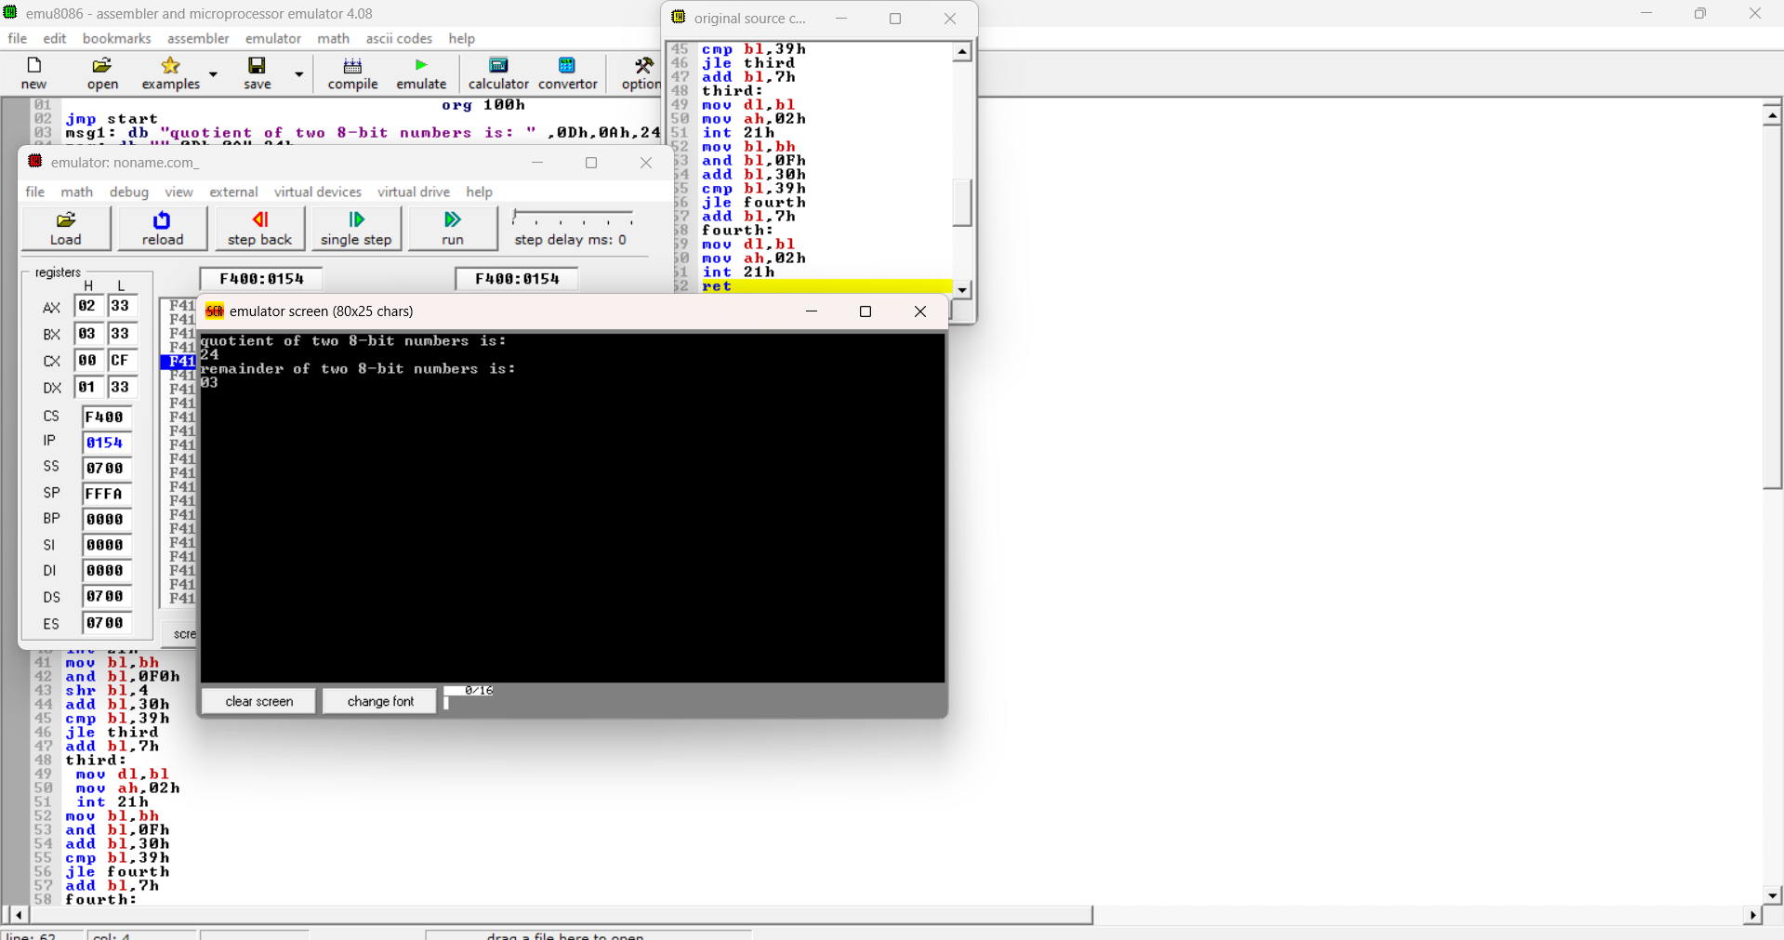

2. Write a program in assembly language to perform division of 16-bit data.

org 100h

jmp start

msg1 : db "Remainder of two 16-bit numbers is: " ,0Dh,0Ah,24h

msg : db "" ,0Dh,0Ah,24h

msg2 : db "Quotient of two 16-bit numbers is: " ,0Dh,0Ah,24h

start:

mov dx,msg1

mov ah,09h

int 21h

mov dx,0000h

mov ax,0FFFh

mov bx,0091h

div bx

mov bx,ax

mov cx,dx

mov ah,ch

and ah,0F0h

shr ah,4

add ah,30h

cmp ah,39h

jle first

add ah,7h

first:

mov dl,ah

mov ah,02h

int 21h

mov ah,ch

and ah,0Fh

add ah,30h

cmp ah,39h

jle second

add ah,7h

second:

mov dl,ah

mov ah,02h

int 21h

mov ah,cl

and ah,0F0h

shr ah,4

add ah,30h

cmp ah,39h

jle third

add ah,7h

third:

mov dl,ah

mov ah,02h

int 21h

mov ah,cl

and ah,0Fh

add ah,30h

cmp ah,39h

jle fourth

add ah,7h

fourth:

mov dl,ah

mov ah,02h

int 21h

mov dx,msg

mov ah,09h

int 21h

mov dx,msg2

mov ah,09h

int 21h

mov ah,bh

and ah,0F0h

shr ah,4

add ah,30h

cmp ah,39h

jle fifth

add ah,7h

fifth:

mov dl,ah

mov ah,02h

int 21h

mov ah,bh

and ah,0Fh

add ah,30h

cmp ah,39h

jle sixth

add ah,7h

sixth:

mov dl,ah

mov ah,02h

int 21h

mov ah,bl

and ah,0F0h

shr ah,4

add ah,30h

cmp ah,39h

jle seventh

add ah,7h

seventh:

mov dl,ah

mov ah,02h

int 21h

mov ah,bl

and ah,0Fh

add ah,30h

cmp ah,39h

jle eigth

add ah,7h

eigth:

mov dl,ah

mov ah,02h

int 21h

mov ah,4ch

int 21h

